**Step 1 - Install Java on your computer**

Download and install the **Java Software Development Kit (JDK)** [here](http://www.oracle.com/technetwork/java/javase/downloads/index.html).

[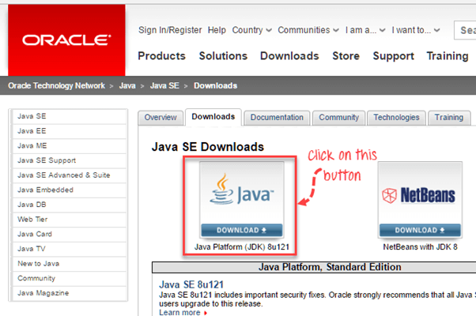](https://www.guru99.com/images/2-2017/022017_1205_Guidetoinst1.png)

Next –

[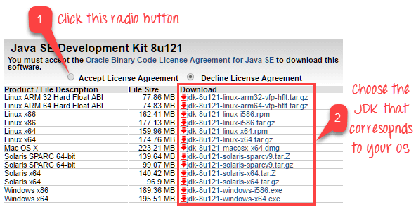](https://www.guru99.com/images/2-2017/022017_1205_Guidetoinst2.png)

This JDK version comes bundled with Java Runtime Environment (JRE), so you do not need to download and install the JRE separately.

Once installation is complete, open command prompt and type “java”. If you see the following screen you are good to move to the next step

[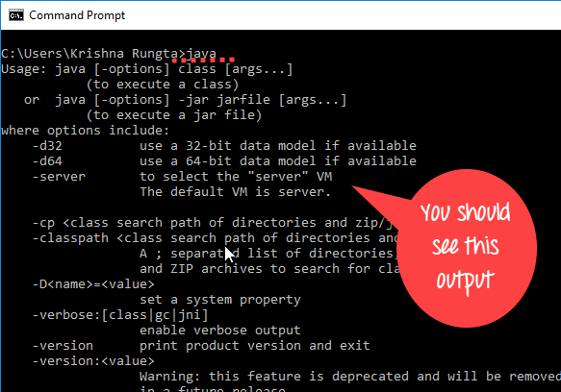](https://www.guru99.com/images/2-2017/022017_1205_Guidetoinst_24_7_1.png)

**Step 2 - Install Eclipse IDE**

Download latest version of **"Eclipse IDE for Java Developers"** [here](http://www.eclipse.org/downloads/). Be sure to choose correctly between Windows 32 Bit and 64 Bit versions.

[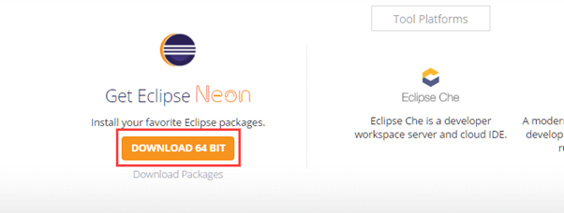](https://www.guru99.com/images/2-2017/022017_1205_Guidetoinst3.png)

You should be able to download an exe file named "eclipse-inst-win64" for Setup.

[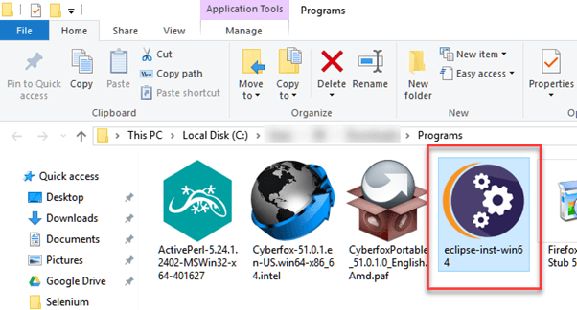](https://www.guru99.com/images/2-2017/022017_1205_Guidetoinst4.png)

Double-click on file to Install the Eclipse. A new window will open. Click Eclipse IDE for Java Developers.

[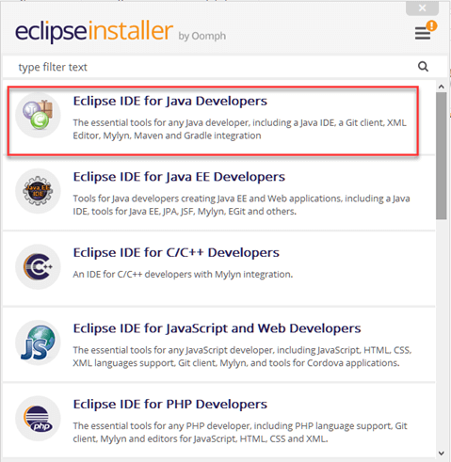](https://www.guru99.com/images/2-2017/022017_1205_Guidetoinst5.png)

After that, a new window will open which click button marked 1 and change path to "C:\eclipse". Post that Click on Install button marked 2

[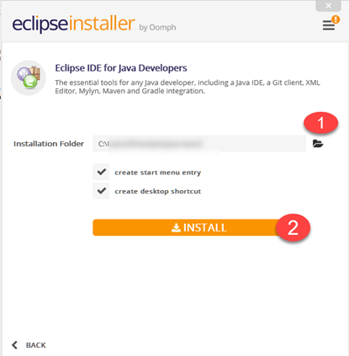](https://www.guru99.com/images/2-2017/022017_1205_Guidetoinst6.png)

After successful completion of the installation procedure, a window will appear. On that window click on Launch

[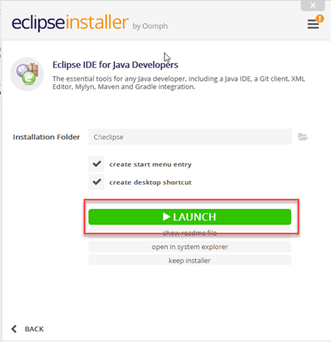](https://www.guru99.com/images/2-2017/022017_1205_Guidetoinst7.png)

This will start eclipse neon IDE for you.

**Step 3 - Download the Selenium Java Client Driver**

You can download the **Selenium Java Client Driver** [here](http://seleniumhq.org/download/). You will find client drivers for other languages there, but only choose the one for Java.

[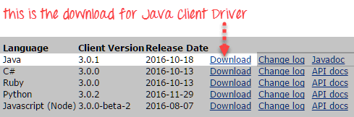](https://www.guru99.com/images/download_java_client_driver_1.png)

This download comes as a ZIP file named "selenium-2.25.0.zip". For simplicity, extract the contents of this ZIP file on your C drive so that you would have the directory "C:\selenium-2.25.0\". This directory contains all the JAR files that we would later import on Eclipse.

**Step 4 - Configure Eclipse IDE with WebDriver**

1. Launch the "eclipse.exe" file inside the "eclipse" folder that we extracted in step 2. If you followed step 2 correctly, the executable should be located on C:\eclipse\eclipse.exe.
2. When asked to select for a workspace, just accept the default location.

[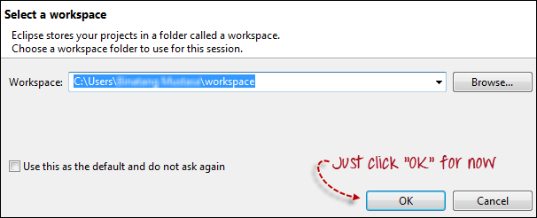](https://www.guru99.com/images/configure_eclipse_1b.png)

3. Create a new project through File > New > Java Project. Name the project as "newproject".

[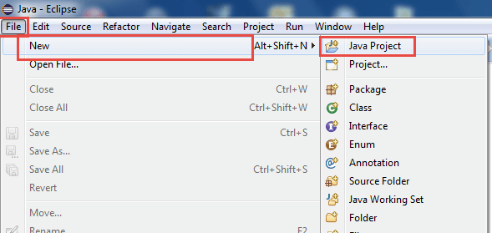](https://www.guru99.com/images/cassandra/021316_1152_SeleniumIns1.png)

A new pop-up window will open enter details as follow

1. Project Name
2. Location to save project
3. Select an execution JRE
4. Select layout project option
5. Click on Finish button

[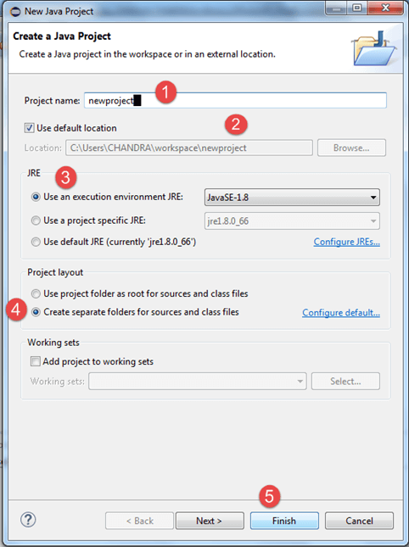](https://www.guru99.com/images/cassandra/021316_1152_SeleniumIns2.png)

4. In this step,

1. Right-click on the newly created project and
2. Select New > Package, and name that package as "newpackage".

[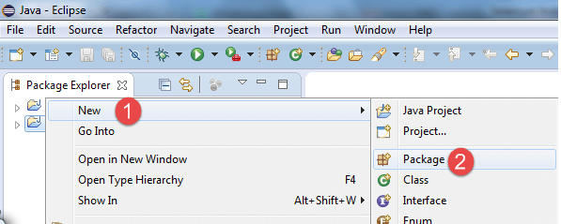](https://www.guru99.com/images/cassandra/021316_1152_SeleniumIns3.png)

A pop-up window will open to name the package,

1. Enter the name of the package
2. Click on Finish button

[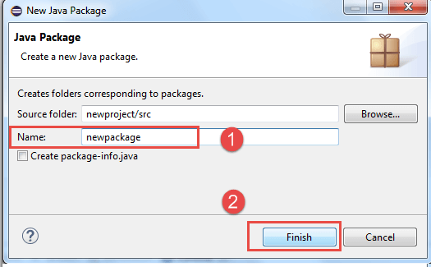](https://www.guru99.com/images/cassandra/021316_1152_SeleniumIns4.png)

5. Create a new Java class under newpackage by right-clicking on it and then selecting- New > Class, and then name it as "MyClass". Your Eclipse IDE should look like the image below.

[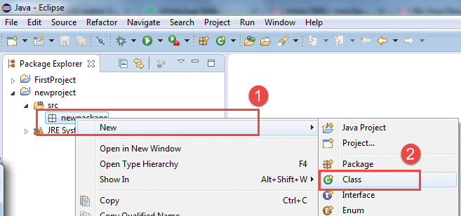](https://www.guru99.com/images/cassandra/021316_1152_SeleniumIns5.png)

When you click on Class, a pop-up window will open, enter details as

1. Name of the class
2. Click on Finish button

[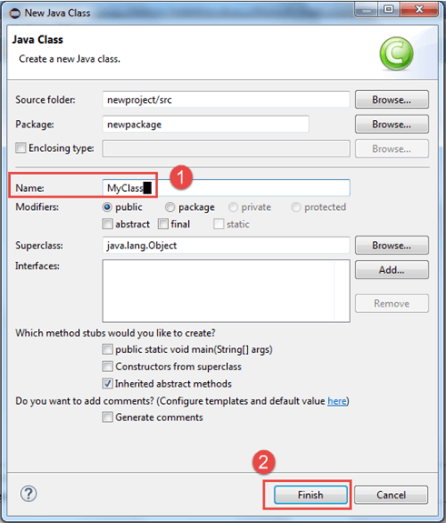](https://www.guru99.com/images/cassandra/021316_1152_SeleniumIns6.png)

This is how it looks like after creating class.

[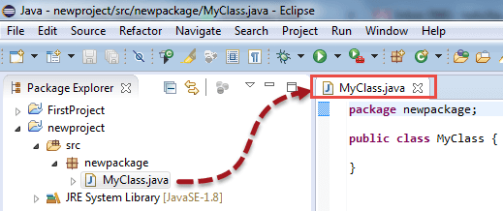](https://www.guru99.com/images/cassandra/021316_1152_SeleniumIns7.png)

Now selenium WebDriver's into Java Build Path

In this step,

1. Right-click on "newproject" and select **Properties**.
2. On the Properties dialog, click on "Java Build Path".
3. Click on the **Libraries** tab, and then
4. Click on "Add External JARs.."

[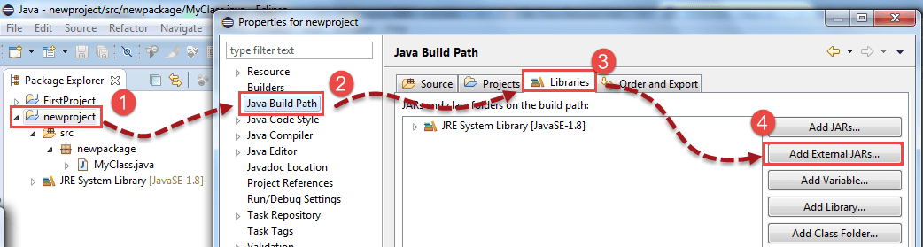](https://www.guru99.com/images/cassandra/021316_1152_SeleniumIns8.png)

When you click on "Add External JARs.." It will open a pop-up window. Select the JAR files you want to add.

[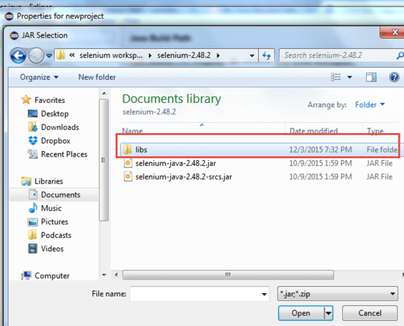](https://www.guru99.com/images/cassandra/021316_1152_SeleniumIns9.png)

After selecting jar files, click on OK button.

Select all files inside the lib folder.

[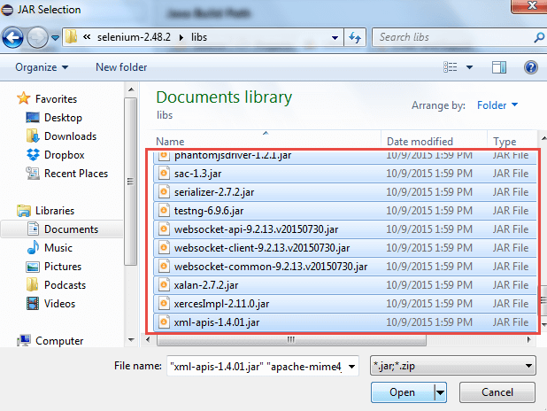](https://www.guru99.com/images/cassandra/021316_1152_SeleniumIns10.png)

Select files outside lib folder

[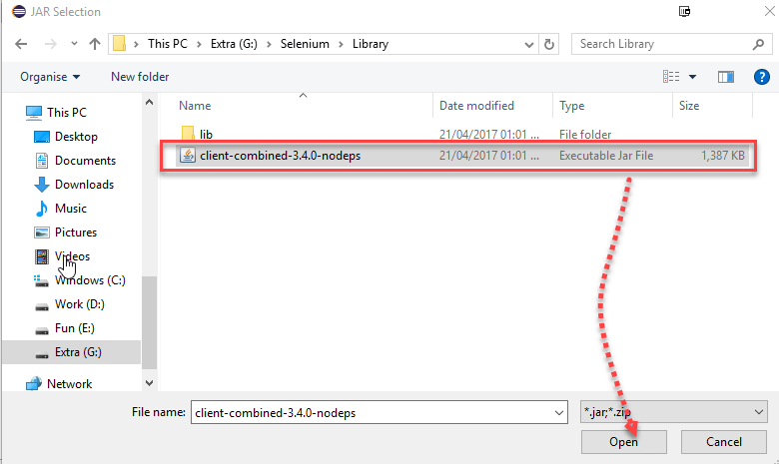](https://www.guru99.com/images/2-2017/022017_1205_Guidetoinst_24_7_2.png)

Once done, click "Apply and Close" button

[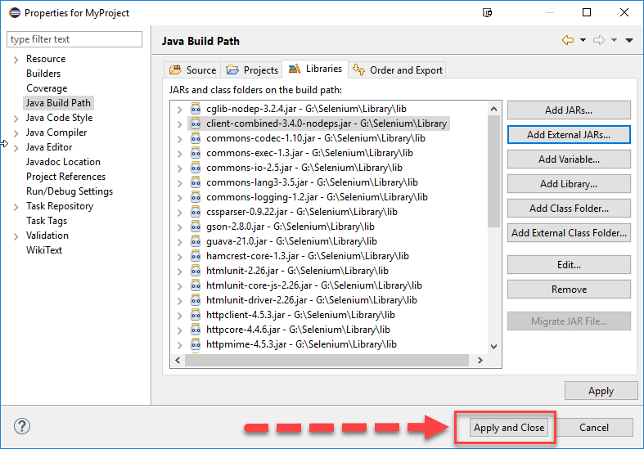](https://www.guru99.com/images/2-2017/022017_1205_Guidetoinst_24_7_3.png)

6. Add all the JAR files inside and outside the "libs" folder. Your Properties dialog should now look similar to the image below.

[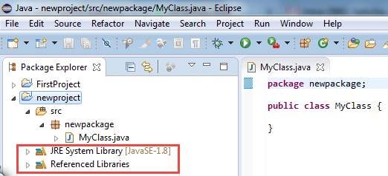](https://www.guru99.com/images/cassandra/021316_1152_SeleniumIns11.png)

7. Finally, click OK and we are done importing Selenium libraries into our project.